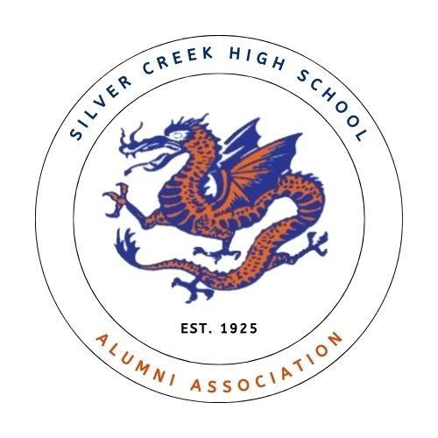

Dear Friend of Silver Creek High School,

Silver Creek Alumni Association is writing to extend an invitation to you to be a sponsor for the upcoming Silver Creek High School Alumni Association Banquet. The event is scheduled to take place on Saturday, June 27, 2026 at Silver Creek High School.

The Silver Creek Alumni event promises to be a fantastic evening filled with a
delicious catered dinner by Schnitzelbank Catering, fun, laughter, and plenty of time to reconnect with old classmates and friends.

It takes a community to accomplish great things, and it is the hope of the SC Alumni Association that our valued local businesses will partner with us on this venture to “make it happen”! Together we can ensure a wonderful evening for attendees and continued generosity in the form of scholarships to deserving Silver Creek students. All Sponsorship donations are dedicated to our Scholarship fund, which will be given to eligible graduating students at the Awards Program on May 13th. Our Scholarship recipients are recognized at our annual Banquet in June. Your support will be sincerely appreciated and acknowledged throughout the event.

Enclosed, please find detailed information about the various sponsorship levels available, along with the associated benefits and recognition opportunities.

Thank you for considering our sponsorship invitation. Should you have any questions or require further information, please do not hesitate to contact me directly.

Thank you for your time, consideration, and continued support.

Emma Haas
SC Alumni Association
Vice President 502-773-3022 scalumassoc@gmail.com


Silver Creek Alumni Association
SPONSORSHIP / DONATION FORM
SPONSOR INFORMATION
Name or business name how you would like it to appear in promotional materials.
Name (company &/or person): ________________________________________________
Street Address: _______________________________________________________________
City/State/Zip: ________________________________________________________________
Contact: _____________________________________________________________________
Phone: ____________________________E-mail: ___________________________________

SPONSORSHIP LEVEL
Yes, I/we would love to support Silver Creek Alumni Association as a Sponsor
- Platinum Inferno Level - $500
- Gold Flame Level – $250

- Silver Scale Level - $100
- Bronze Blaze Level - $_________

We appreciate your support! Please send the sponsorship form and checks payable to Silver Creek Alumni Association by May 4, 2026, to the address below.
Completed forms may also be emailed to scalumassoc@gmail.com. Thank you!

Silver Creek Alumni Association
P.O. BOX 311 • Sellersburg, Indiana 47172

